CHAPTER 1: BACKGROUND AND PROBLEM DEFINITION

  - INTRODUCTION:

The field of robotics is experiencing exponential growth through the amalgamation of communication engineering, mechanical design, and embedded systems to create highly flexible autonomous platforms. As industrialization and urban density increase, fire hazards have emerged as one of the most significant threats to life and property. High temperatures, structural instability, and toxic smoke often create environments where human intervention is physically impossible or life-threatening. Traditional firefighting methods, while effective, place first responders at extreme risk, particularly in scenarios involving explosive materials or chemical leaks.
While conventional firefighting robots have been developed to mitigate these risks, they are frequently hampered by technical limitations that restrict their real-world utility. Many current systems rely on short-range communication protocols, such as Bluetooth or Radio Frequency (RF), which typically restrict the operational radius to less than 500 meters. Furthermore, these units often depend on static power sources or limited battery capacities, leading to potential mission failure if the robot's power depletes in an off-grid or inaccessible hazardous zone.
This project, entitled “Solar Powered Wi-Fi controlled Fire Fighting Robot using Arduino Application,” aims to overcome these barriers by providing a sophisticated first-responder unit capable of navigating hazardous zones without endangering human lives. The core innovation of this system lies in its ability to bridge the gap between autonomous hardware response and global long-distance connectivity. By utilizing the internet as a medium via NodeMCU (ESP8266) integration, the system allows for remote oversight from locations potentially thousands of miles away, transforming the robot into a truly global IoT-enabled safety device.
To ensure constant operational readiness, the robot utilizes a robust hybrid power architecture. It integrates a 12V monocrystalline solar panel for renewable energy harvesting while maintaining AC-to-DC grid compatibility for backup charging. This dual-source infrastructure ensures the onboard Li-ion battery bank remains charged, allowing the robot to remain functional in remote, off-grid locations where traditional power sources are unavailable.
The sensing layer of the robot is designed for comprehensive environmental awareness. It features a multidirectional array of three flame sensors that provide a 180-degree field of view, effectively eliminating the "blind spots" common in single-sensor models. Additionally, an MQ-series smoke sensor is integrated for precise gas and hazard verification, ensuring the system can distinguish between thermal signatures and actual fire-related threats.
Mechanical actuation and suppression are handled through a high-precision execution layer. The robot’s mobility is driven by an L298N motor driver, while fire suppression is managed by a submersible pump housed within an onboard water reservoir. A standout feature of this design is the front-mounted servo motor, which facilitates “active sweeping”. Rather than spraying water at a fixed point, the servo dynamically moves the nozzle back and forth to ensure the extinguishing agent covers the entire base of the fire.
Software implementation is managed through the Arduino IDE, utilizing Pulse Width Modulation (PWM) for servo control and serial communication for the Wi-Fi link. The system is interfaced with an Android-based Graphical User Interface (GUI), which enables the user to monitor real-time sensor data and manually recover the vehicle to a safe zone once the fire is neutralized. By combining long-range connectivity with autonomous sensing and precision actuation, this project provides a scalable, self-sustained solution for hazardous environment mitigation, offering a foundation for future advancements in AI-driven disaster management.

  - PROBLEM STATEMENT:
In many educational institutions and organizations, attendance management is still carried out using traditional or partially automated systems. These systems face several practical challenges that reduce their efficiency, reliability, and security. The major problems associated with existing attendance systems are discussed below:
1.2.1 Operational Risks in Hazardous Environments
High temperatures and toxic environments often prevent firefighting personnel from safely accessing fire sites, leading to massive property damage and loss of human life. Traditional human-led intervention is particularly restricted when explosive materials are present, making direct suppression efforts physically impossible. In these high-risk scenarios, human responders face life-threatening conditions including structural collapse and respiratory failure. Robotic platforms provide a necessary alternative for fire suppression in areas where humans cannot operate safely. Without an autonomous or remote-controlled solution, many fire incidents in restricted zones remain uncontained until they cause catastrophic damage.
1.2.2 Communication Range and Protocol Constraints: While conventional firefighting robots have been developed to mitigate risks, they are frequently hampered by short-range communication protocols. These technologies, such as Bluetooth or Radio Frequency (RF), typically restrict the robotic unit to a limited operational radius of approximately 500 meters or less. This restriction prevents the deployment of robots in large-scale industrial complexes or remote hazardous zones where the operator must remain at a significant distance. The lack of a long-range communication medium means that once the robot moves out of sight or signal range, it becomes unresponsive. Addressing this gap requires shifting from localized RF control to internet-based global connectivity
1.2.3 Power Dependency and Mission Sustainability: The lack of a self-sustaining power source often results in critical mission failure when a robot's battery depletes in an off-grid hazardous zone. Conventional robots depend on static power sources or standard battery packs that require frequent manual recharging. If a mission extends beyond the initial battery life, the robot may become stranded, rendering it useless for suppression or recovery. To ensure constant operational readiness, there is a critical need for a hybrid-power architecture that can harvest ambient energy. Without energy integration like solar harvesting, robots remain tethered to the availability of the local power grid.
1.2.4 Sensing Limitations and Detection "Blind Spots: Many traditional firefighting robotic systems utilize single-sensor models that offer a very narrow field of view for detection. This creates significant "blind spots" during the initial reconnaissance phase, where the robot might fail to identify a secondary ignition source or a flanking fire. Furthermore, reliance on a single sensor type increases the probability of false alarms from non-fire-related thermal signatures. There is a technical requirement for a multidirectional array that provides comprehensive 180-degree coverage. A robust detection layer must synchronize data from multiple sensors to ensure high accuracy and comprehensive hazard verification.
1.2.5 Precision and Resource Management in Suppression: Standard firefighting robots often employ fixed water nozzles that cannot target specific angles or varying flame heights. This static design leads to a significant waste of extinguishing agents, as the water may not be hitting the actual base of the fire. Managing a limited onboard water reservoir is crucial, and fixed systems often exhaust their supply before the hazard is neutralized. Implementing "active sweeping" through servo-controlled mechanisms is necessary to dynamically align the nozzle with the thermal source. Without precision targeting, the efficiency of the suppression phase remains low and resource heavy.
1.2.6 Challenges in Vehicle Recovery and Post-Operation A common failure in robotic firefighting is the inability to recover the vehicle after the autonomous suppression mission is complete. Once a robot has exhausted its water supply or fulfilled its autonomous logic, it may remain in a high-heat zone, risking damage to its internal electronics. Many systems lack a remote interface that allows for manual positioning after the primary task is finished. Integrating an Android-based GUI with directional controls is essential to facilitate manual recovery to a safe zone. Without this manual override, the hardware-level autonomy remains incomplete as the unit cannot be retrieved for future missions.
Table 1.1: Comparison of Traditional and Proposed Attendance System
Parameter | Conventional Firefighting Systems | Proposed Solar-IoT Firefighting Robot
Power Infrastructure | Dependent on static grids or DC batteries with low uptime. | Hybrid Solar + AC architecture for 24/7 autonomous readiness.
Communication Range | Limited to 500m radius via RF or Bluetooth (10–20m). | Global long-distance oversight via IoT and Wi-Fi connectivity.
Detection Coverage | Single sensors causing significant "blind spots". | 180° multidirectional array with 3 flame and smoke sensors.
Suppression Method | Fixed water nozzles that wastewater and miss angles. | Servo-controlled "Active Sweeping" for precision targeting.
Operational Control | Manual switches or high human proximity required. | Autonomous navigation with remote manual GUI override.
Data Monitoring | No real-time logs or status feedback. | Real-time serial data logs on Android-based GUI.
Mission Safety | High risk to human life in toxic/explosive areas. | Zero-risk "First Responder" deployment in hazardous zones.
System Intelligence | Hardwired logic with limited scalability. | Dual-core intelligence using Arduino and NodeMCU.

  - OBJECTIVES OF PROJECT:
The main objective of this project is to design and develop a smart, secure, and efficient attendance management system using fingerprint authentication and IoT technology. The system aims to overcome the limitations of traditional attendance methods by providing accurate, real-time, and automated attendance recording. The specific objectives of the project are as follows:
1.3.1 Autonomous Hazard Mitigation: The primary goal is to design a robotic unit capable of detecting and extinguishing fires in hazardous zones without requiring direct human intervention. By automating the suppression process, the system significantly reduces the risk to human life in environments with high temperatures or toxic smoke. The robot acts as an intelligent first responder, navigating toward thermal sources to neutralize threats before they escalate.
1.3.2 Renewable Energy Integration: To ensure continuous operation in off-grid or remote locations, the project implements a self-sustaining power architecture using solar energy harvesting. This hybrid system utilizes 12V monocrystalline solar panels alongside an AC charging circuit to maintain the onboard battery bank. Such an infrastructure ensures that the robot remains functional and mission-ready even during power grid failures or in locations without traditional power sources.
1.3.3 Real-Time Remote Monitoring: The system facilitates real-time data transmission and remote control via an Android-based Graphical User Interface (GUI). This allows supervisors to monitor environmental sensor data, including flame and smoke levels, from a safe distance. The interface provides a bidirectional communication loop where users can receive live status logs and issue manual commands to reposition the vehicle as needed.
1.3.4 Precision Suppression and Detection. The project aims to achieve high-accuracy detection and suppression through a synchronized multi-sensor layer and "active sweeping" actuation. By utilizing a 180-degree flame sensor array, the robot eliminates "blind spots" during the initial reconnaissance phase. Precision suppression is then handled by a servo-controlled nozzle that dynamically targets the base of the fire, ensuring extinguishing agents are used efficiently rather than at a fixed point.
  - SCOPE OF PROJECT:
The scope of this project is cantered on developing a scalable and intelligent first-responder robotic platform designed to operate in high-risk environments where human safety is compromised. By integrating communication engineering and mechanical design, the project aims to create a cohesive system capable of mitigating fire hazards through both autonomous logic and remote intervention. The technical boundaries of this scope encompass the transition from localized hardware to global long-distance connectivity.

1.4.1 Global IoT Connectivity and Remote Oversight: Long-Distance Monitoring: The system enables remote oversight from locations potentially thousands of miles away by utilizing the internet as a medium.
- Cloud Integration: It leverages a NodeMCU (ESP8266) to act as a bridge between the physical robot and a cloud-based interface.
- Wi-Fi Protocols: Communication is facilitated via serial data transmission between the robot and a remote smartphone or tablet using Wi-Fi.
- Bidirectional Communication: The scope includes a feedback loop that allows for real-time status updates and manual command reception.
- Safeguarding Human Life: By providing a safer alternative for managing hazards in restricted environments, the system minimizes direct human exposure to danger.

1.4.2 Hybrid Power Infrastructure and Sustainability
To ensure constant operational readiness, the project implements a self-sustaining power architecture that harvests ambient energy. The setup utilizes a 12V monocrystalline solar panel to capture energy during daylight hours. It maintains AC grid compatibility through a charging circuit to ensure readiness when solar intensity is insufficient. This hybrid approach maintains an onboard Li-ion battery bank to power the localized control logic and actuators. The power system ensures the robot remains functional in remote locations where traditional power sources are unavailable. The architecture allows for 24/7 readiness by prioritizing solar energy and switching to AC power as needed.

1.4.3 Multidirectional Sensing and Hazard Verification
The sensing layer is composed of a specialized array designed to eliminate blind spots and provide comprehensive environmental data.

1.4.4 180-Degree Coverage
- Three IR flame sensors are positioned at specific angles to capture directional heat data.
- These sensors allow the Arduino to calculate fire coordinates for autonomous navigation.
- An MQ-series smoke sensor monitors air quality to provide secondary hazard verification
- Raw analogy signals are processed by the microcontroller to determine if smoke or fire density exceeds predefined safety limits.
- The project scope covers the synchronization of data from multiple sensors to create a cohesive response loop.

1.4.5 Precision Suppression and Active Sweeping
1. Servo-Controlled Nozzle: A front-mounted servo motor dynamically aligns the water nozzle based on the highest flame sensor reading.
2. Active Sweeping Logic: The servo moves the nozzle back and forth to ensure the extinguishing agent covers the entire base of the fire.
3. Submersible Delivery: A submersible pump is activated to deliver water from an onboard reservoir to the suppression nozzle.
4. Optimized Efficiency: This method increases extinguishing efficiency by targeting flames at different angles without moving the entire chassis.
5. Robotic Mobility: An L298N motor driver manages the DC motors to move the chassis toward or away from identified hazards

1.4.6 User Interface and Vehicle Recovery
A significant portion of the scope involves developing a Graphical User Interface (GUI) for post-operation control and status monitoring the project utilizes an Android application to display real-time system status, such as "Fire Detected" or "Safe". The interface provides a manual override feature, allowing the user to take control after a fire is neutralized. Manual directional arrows enable the operator to navigate the platform back to a docking station or safe zone. Using NodeMCU’s Wi-Fi capabilities, the user can remotely reposition the robot even from vast distances. The project serves as a technical foundation for future AI-driven disaster management and environmental mapping

  - LIMITATIONS OF PROJECT:
While the system is a functional prototype designed for hazard mitigation, it has certain constraints that define its current operational environment. These limitations provide context for the technical boundaries of the "First Responder" platform.
1.5.1 Payload and Mechanical Torque Constraints
The volume of the water tub is restricted by the motor torque capacity of the current robotic chassis. A larger water reservoir would necessitate more powerful high-torque motors to maintain consistent mobility and navigation speed. Increased payload weight could impact the structural integrity and battery life of the unit during long-duration suppression missions.

1.5.2 IoT Connectivity and Range Dependencies
IoT control via the NodeMCU (ESP8266) is strictly dependent on the range and strength of the local Wi-Fi network or mobile hotspot. In massive industrial or disaster zones, signal interference and degradation could negatively impact the reliability of the manual override. Global connectivity via the internet may introduce minor latency delays compared to short-range direct radio frequency protocols.
1.5.3 Surface Navigation and Terrain Restrictions
The current wheel and motor design is primarily optimized for flat, indoor surfaces such as warehouse floors. The robot may struggle with uneven outdoor terrain, scattered debris, or steep inclines commonly found in disaster sites. Without advanced off-road suspension, the unit’s ability to navigate over large physical obstructions is limited.
1.5.5 Extinguishing Agent Versatility
The robot currently utilizes water as the primary extinguishing agent from its onboard reservoir Water is not suitable for electrical or chemical fires, where agents such as foam or C02 would be required to prevent further hazards. The system lacks the multi-nozzle infrastructure to switch between different suppressants based on the fire type.

  - ORGANIZATION OF PROJECT:

This report is organized into different chapters, each focusing on a specific aspect of the project to provide a clear and structured understanding of the proposed system.
Chapter 1: Background and Problem Definition
This chapter introduces the fundamental concepts of the firefighting robot, defining the operational risks and technical barriers that necessitate an autonomous, solar-powered solution. It outlines the core objectives, scope, and specific limitations addressed by the proposed robotic platform.

Chapter 2: Literature Review
This section provides a comprehensive analysis of existing firefighting technologies and academic research to identify current technical gaps in range and power. It includes a comparative study of conventional systems against the proposed IoT-enabled hybrid architecture
Chapter 3: Conceptual Framework of Proposed System
This chapter details the high-level design and working principle of the robot, focusing on the "Sense-Analyse-Act" operational cycle. It presents the system block diagram and the logic behind the "active sweeping" suppression mechanism.

Chapter 4: System Architecture and Implementation Details
This section describes the technical integration of hardware and software, covering the Arduino-based local logic and NodeMCU-based global connectivity. It lists the specific requirements for the sensing, processing, and execution layers of the robot.

Chapter 5: System Implementation and Experimental Evaluation
This chapter covers the physical assembly, hardware integration steps, and the results of system testing and validation. It includes visual documentation and an analysis of the robot's performance in terms of response time and sensing accuracy.

Chapter 6: Conclusion and Key Findings
This section summarizes the project's success in bridging the gap between hardware autonomy and long-distance connectivity via the internet. It highlights key technical findings, such as the efficiency of 180-degree multi-sensor verification.
Chapter 7: Contributions and Future Enhancements
The final chapter discusses the project's contribution to hazardous environment mitigation and identifies potential upgrades like computer vision and swarm robotics. It defines the future scope for scaling the platform into a more advanced disaster management solution.

CHAPTER 2: LITERATURE REVIEW

  - LITERATURE REVIEW:

The field of robotics is undergoing significant growth by integrating communication engineering, mechanical design, and embedded systems to create flexible autonomous platforms. Current research highlights a critical need to overcome the 500-meter range limitation of conventional technologies through the development of IoT-enabled firefighting units monitored over vast distances via Wi-Fi. Literature identifies several technical challenges in existing systems, including high false alarms from sunlight in UV sensors, restricted mobility in tethered AC-powered bots, and the short battery life of aerial detection networks. Recent studies advocate for hybrid-power architectures and multi-sensor fusion to ensure constant operational readiness and eliminate "blind spots" in hazardous, off-grid environments.
Table 2.1: Literature Review Summary of Existing Systems
Sr.  No. | Author/Year | Technology Used | Advantages | Disadvantage
1. | Sharma et al.,  2023 | RF controlled Fire Fighting Robot | Low Latency in short range line-of-sight | Limited Range.  No Remote Iot logs
2. | Chen & Wei | Purely Solar Powered Robot | Carbon -neutral; ecofriendly operation | Fails in low light/indoor environment.
3. | Roberts et al.,  2023 | Single UV flame  sensor | High Sensitivity to ultraviolet radiation | High false alarms from sunlight.
4. | Kumar & Singh ,2024 | Bluetooth-based Navigation | Easy smart phone pairing, low power. | Range restricted to 10 -20 meters
5. | Lopez et al.,2024 | Fixed nozzle water pump | Simple mechanical design; high flow rate | Wastes water; cannot target specific angles.
6. | Tanaka et al.,  2024 | Raspberry Pi Vision Bot | Uses AI/CAMERA for fire detection | High Power Consumption;  Requires GPU
7. | Smith & J., 2024 | GSM- Based Fire Alert | Works in areas without Wi-Fi | High SMS Latency; No real time navigation
8. | Gupta et al.,  2024 | Ultrasonic OBSTACLE Avoidance | Effective path planning | Only detects Physical walk; Ignores fire
9. | Muller et al.,  2024 | AC -Powered Fire suppression | Unlimited Powe for heavy Pumps | Tethered by wires; restricted Mobility
10. | Ahmed et al.,  2025 | Swarm Firefighting bots | Covers large industrial areas. | High Cost, Complex Coordination logic
11. | Patel et al.,2025 | VOC/ Smoke gas analysis | Precise detection of chemical fires | Slow response time for actual flame
12. | Zhang et al., | LiDOR Mapping Robot | Creating 3D maps of disaster Zone | External expensive Hardware
13. | Ivanov et al.,  2025 | Thermal Camera Integration | Sees through thick smoke | Thermal noise in high heat zones.
15. | Lee & Park,  2025 | Lora Wan Safety Bot | Long range Low Power | Very low data bandwidth (No GUI Logs
16. | Brown et al., 2025 | DC- only Solar Charging | Simple electrical Architecture. | Cannot operate during Monsoon/Night
17. | Agrawal, 2025 | UAV-IoT Networks | High-altitude fire detection | Short battery life; complex flight
18. | Guruprasad et al., 2024 | Multi-Sensor Fusion | Autonomous sensing and fusion | Complex software integration
19. | Maruf et al., 2026 | PID Controller | Stable autonomous navigation | Difficult to tune gain parameters
20. | Ding et al., 2025 | Situation Assessment | Real-time flame detection algorithm | Requires high processing power

  - COMPARATIVE ANALYSIS:
The comparative analysis of various firefighting technologies reveals that traditional systems often fall short in mission sustainability and operational range. While RF and Bluetooth-controlled robots provide low-latency response, they are restricted by a short communication radius and lack real-time IoT status feedback. Furthermore, static power dependencies in conventional units often lead to mission failure in off-grid hazardous zones, a gap addressed by the implementation of hybrid solar-AC architectures. This project bridges these technical deficiencies by integrating a 180-degree multi-sensor sensing array with global cloud-based monitoring to ensure zero-risk deployment in toxic environments.
Table 2.2: Comparative Performance Matrix of Firefighting Systems
SYSTEM TYPE | POWER SUSTAINABILITY | RANGE/ CONNECTIVITY | DETECTION ACCURACY
Manual Firefighting | 1 | 2 | 1
RF/Bluetooth Robot | 2 | 3 | 2
Purely Solar Robot | 3 | 3 | 3
IoT-Enabled System | 3 | 4 | 4
Proposed Hybrid System | 5 | 5 | 5

  - RESEARCH GAP IDENTIFICATION:

The research gap identification reveals that while conventional technologies often restrict robotics to a limited radius of 500 meters, this project aims to bridge the gap between localized autonomous hardware and global remote oversight. A critical mission failure occurs in traditional systems when the lack of a self-sustaining power source causes a robot's battery to deplete in off-grid hazardous zones. Furthermore, many existing systems utilize single-sensor models that lead to detection "blind spots," necessitating a robust multidirectional array to ensure high accuracy during reconnaissance. Suppression inefficiency is also a common issue, as fixed water nozzles frequently wastewater and cannot target specific angles compared to "active sweeping" mechanisms. There is a significant technical deficiency in current platforms regarding connectivity, which lacks real-time data logs or cloud integration for vast-distance monitoring. Finally, traditional robots often fail to provide a remote interface for manual recovery, leaving hardware potentially stranded in high-heat zones after fire neutralization.

  - JUSTIFICATION OF PROPOSED WORK:
The justification of the proposed work is cantered on addressing the life-threatening risks faced by human responders in toxic, high-temperature, or explosive environments. By integrating an autonomous first-responder unit, this system significantly reduces the threat to life and property through localized suppression in areas where human visibility and breathability are compromised. The project further justifies its technical necessity by bridging the critical communication gap inherent in traditional systems, which are typically restricted to a 500-meter radius. By utilizing a dual-core intelligence architecture featuring NodeMCU, the robot facilitates global long-distance oversight and manual recovery via the internet, ensuring the system can be monitored from vast distances. Additionally, the implementation of a hybrid solar-AC power architecture ensures mission sustainability in off-grid locations, effectively preventing mission failure due to battery depletion. Finally, the use of a 180-degree multi-sensor array and "active sweeping" precision suppression optimizes detection accuracy and resource management, providing a more efficient and scalable solution for modern disaster management.

CHAPTER 3: CONCEPTUAL FRAMEWORK OF PROPOSED
SYSTEM

  - INTRODUCTION:
The conceptual framework of the proposed system is designed to provide a robust, self-sustaining, and IoT-enabled solution for mitigating fire hazards in environments where human presence is dangerous or impossible. The framework is built upon a "Sense-Analyse-Act" operational cycle, which allows the robotic platform to autonomously identify thermal threats and respond with precision suppression. By integrating communication engineering with mechanical actuation, the system moves beyond localized hardware to achieve global long-distance oversight via the internet.
  - : OVERVIEW OF PROPOSED SYSTEM:
The proposed system, titled “Solar Powered Wi-Fi controlled Fire Fighting Robot using Arduino Application,” is an IoT-enabled robotic platform designed to mitigate fire hazards in restricted or dangerous environments. It utilizes a multi-directional sensing array to capture heat data and a dual-core intelligence architecture for localized navigation and global cloud connectivity. The system effectively bridges the gap between hardware-level autonomy and long-distance monitoring, allowing users to oversee operations from potentially thousands of miles away via a Wi-Fi link.

  - SYSTEM COMPONENTS:
The proposed attendance management system is composed of both hardware and software components that work together to ensure accurate, secure, and real-time attendance recording. Each component has a specific role in the system, and proper integration of these components enables smooth system operation.

3.3.1 Arduino Uno:
This serves as the primary micro-controlling unit that handles real-time localized navigation, threshold comparison, and the servo-nozzle sweep algorithm.

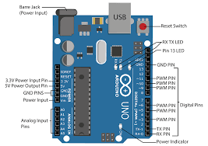
Figure 3.1: Arduino Uno

3.3.2 NodeMCU (ESP8266)
It acts as a communication bridge between the physical hardware and the internet, facilitating serial data transmission to the remote Android GUI.

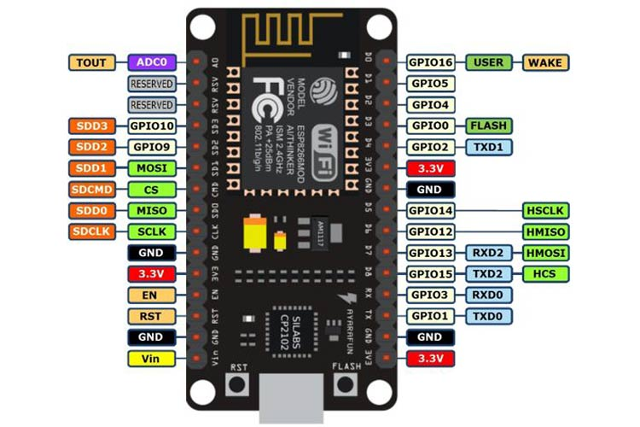
Figure 3.2: NodeMCU (ESP8266)

3.3.3 Flame Sensors (3x Array)
These sensors are positioned at specific angles to provide a 180-degree field of detection for identifying fire coordinates.
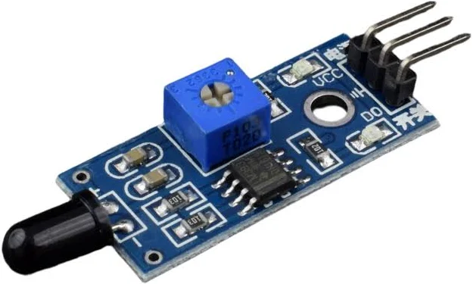
Figure 3.3: Flame Sensors (3x Array)

3.3.4 MQ-Series Smoke Sensor
This component monitors air quality and provides secondary hazard verification by detecting smoke density.
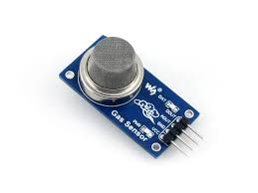
Figure 3.4: Buzzer Module

3.3.5 L298N Motor Driver
This module manages the DC motors to control the mobility of the robotic chassis toward or away from detected hazards.
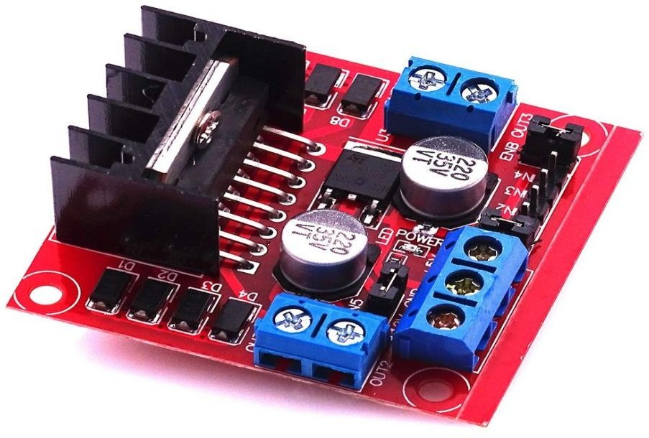
Figure 3.5: L298N Motor Driver

3.3.6 Servo Motor: A front-mounted actuator that dynamically aligns the water nozzle for "active sweeping" across the base of the fire.
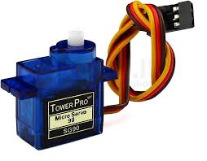
Figure 3.7: Servo Motor
3.3.7 Submersible Pump:
This pump is activated by a relay to deliver water from the onboard reservoir to the suppression nozzle.
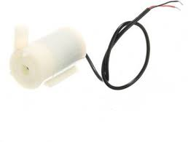
Figure 3.6: Submersible Pump
3.3.8 12V Monocrystalline Solar Panel: Part of the hybrid power architecture, it harvests renewable energy to charge the onboard battery bank during daylight.
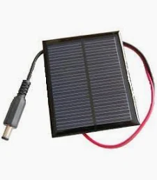
Figure 3.8: 12V Monocrystalline Solar Panel

3.3.9 Android-Based GUI: A mobile application that allows users to monitor real-time status logs and manually recover the vehicle to a safe zone.
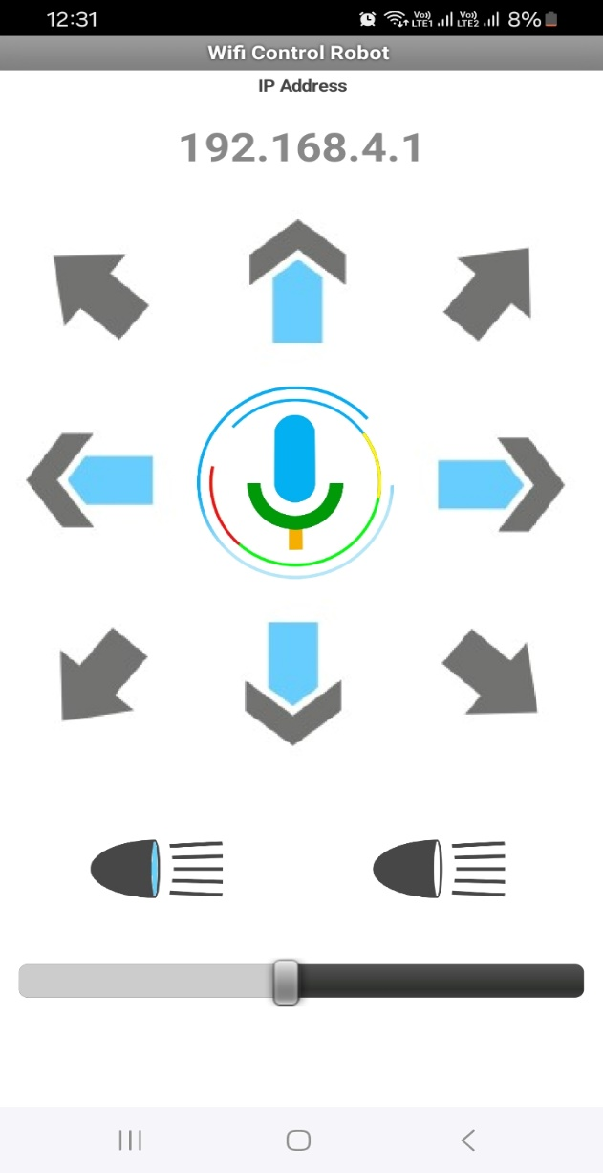
Figure 3.9: Android-Based GUI
  - BLOCK DIAGRAM OF PROPOSED SYSTEM:
The system block diagram illustrates a highly integrated architecture divided into perception, processing, communication, and execution layers. At the top, the hybrid power infrastructure combines solar and AC inputs to maintain a mission-ready battery bank. The perception layer feeds raw data from the 180-degree flame array and smoke sensor into the micro processing layer. The Arduino Uno processes this local logic while communicating bidirectionally with the NodeMCU IoT bridge. This dual-core processing ensures that the robot can act autonomously while remaining under global remote oversight. The execution layer receives commands from the logic units to drive motors, align the servo-nozzle, and activate the water pump. Finally, the presentation layer (Android GUI) closes the loop by providing the user with real-time status logs and manual override controls. This structured flow ensures that detection, analysis, and suppression occur in a synchronized and efficient manner.

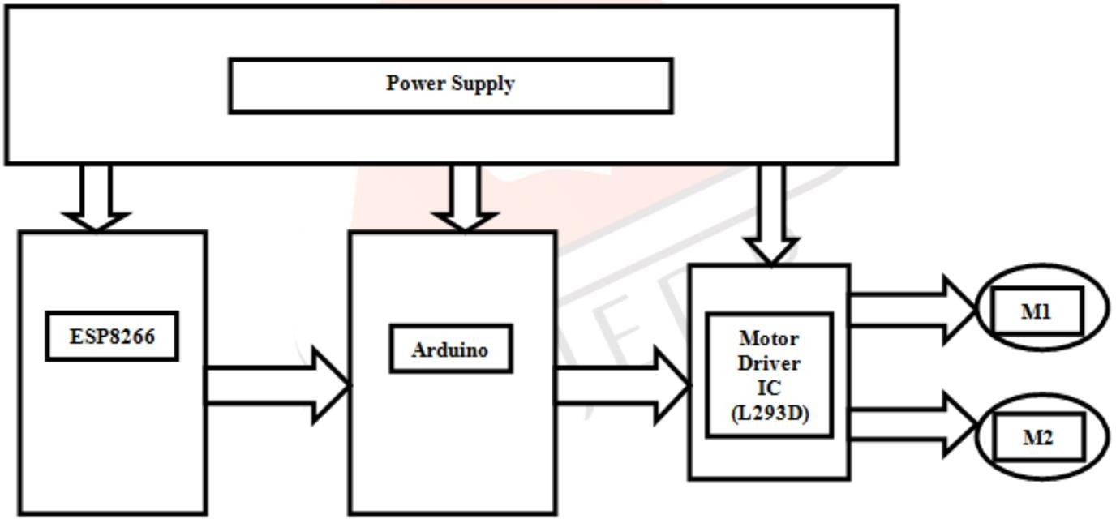

Figure 3.10: Block Diagram of Proposed System

  - WORKING PRINCIPLE:
The operational logic of the robot follows a continuous Sense-Analyse-Act cycle supported by a feedback loop. Initially, the hybrid power system prioritizes solar energy to charge the Li-on battery, switching to AC backup only when solar intensity is low. The 180-degree sensing array constantly monitors for thermal signatures and smoke density; if a threshold is exceeded, the system is armed for suppression. The Arduino calculates target acquisition by comparing sensor signals; for instance, if the left sensor is high, the robot turns left until the centre sensor aligns with the flame. Once the proximity threshold is reached, the Arduino activates a relay to turn on the submersible water pump. Simultaneously, a PWM signal is sent to the front-mounted servo motor to initiate "active sweeping," moving the nozzle back and forth to cover the entire base of the fire. Throughout this process, the NodeMCU transmits real-time "System Status" logs to the Android-based GUI via Wi-Fi. After the fire is extinguished, the operator uses the mobile application's manual directional arrows to recover the vehicle to a docking station. This combination of hardware autonomy and remote positioning ensures safe and effective hazard mitigation.

  - LAYERED ARCHITECTURE OF PROPOSED SYSTEM:
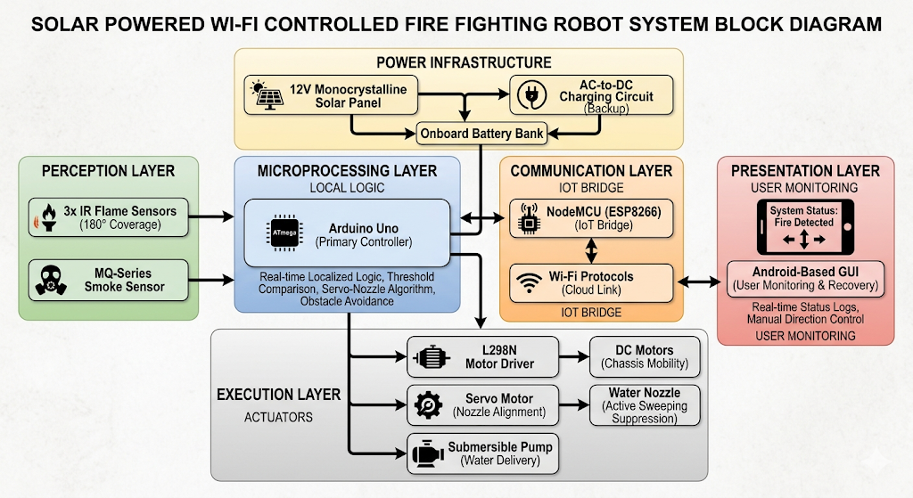
Figure 3.6: Layered Architecture of proposed system

  - ADVANTAGES OF PROPOSED SYSTEM:
- Global Long-Range Control: Operates over vast distances via the internet, overcoming the 500-meter range limit of conventional systems.
- Hybrid Power Sustainability: Utilizes solar energy harvesting to ensure 24/7 mission readiness in off-grid or remote locations.
- Zero-Risk Deployment: Provides a "First Responder" solution that enters toxic or explosive zones without endangering human lives.
- Elimination of Blind Spots: Features a 180-degree multi-sensor array for comprehensive hazard detection and verification.
- Precision Targeting: Employs "Active Sweeping" via a servo-controlled nozzle to cover the entire fire base rather than a single fixed point.
- Dual-Core Reliability: Separates localized navigation logic (Arduino) from global communication tasks (NodeMCU) for more stable operation.
- Real-Time Monitoring: Offers an Android-based GUI for continuous system status updates and environmental sensor logging.
- Efficient Resource Use: Optimized suppression logic targets fire sources accurately, reducing water waste from the onboard reservoir.
- Manual Override Capability: Allows users to manually recover the vehicle to a safe zone after a hazard has been neutralized.
- Scalable Infrastructure: Serves as a technical foundation for future AI-driven disaster management and swarm coordination upgrades.
.

CHAPTER 4: SYSTEM ARCHITECTURE AND
IMPLEMENTATION DETAILS

  - SYSTEM ARCHITECTURE:
The architecture of the robotic platform is designed as a cohesive ecosystem that integrates power management, environmental sensing, and precision actuation. It ensures that the robot can operate autonomously in hazardous zones while maintaining a global link for remote oversight.
4.1.1 Multi-Layered Structural Framework: The system is organized into three primary operational layers: Perception (Sensing), Processing (Control), and Execution (Actuation), all of which are supported by a foundational Hybrid Power Infrastructure. This modular design allows for independent processing of sensor data and mechanical output, ensuring that localized logic does not interfere with global connectivity.

4.1.2 Dual-Core Processing and Communication:
The robot utilizes a "brain" consisting of an Arduino Uno and a NodeMCU (ESP8266) working in tandem. The Arduino manages real-time localized logic, such as threshold comparisons and obstacle avoidance, while the NodeMCU acts as an IoT bridge to transmit sensor logs and receive manual commands from the Android GUI via Wi-Fi.

4.1.3 180-Degree Perception Layer:
For environmental awareness, the system employs a multidirectional sensing array featuring three IR flame sensors and an MQ-series smoke sensor. This configuration provides a full 180-degree field of view to eliminate detection "blind spots," allowing the Arduino to calculate specific fire coordinates based on heat and smoke density.
4.1.4 Execution and Actuation Layer:
Mechanical output is handled by high-accuracy actuators, including an L298N motor driver for chassis mobility and a front-mounted servo motor for nozzle alignment. The suppression system is powered by a submersible pump inside an onboard reservoir, delivering a directed water stream once the robot identifies a thermal target.
4.1.5 Hybrid Power Management Architecture
To ensure mission sustainability in off-grid locations, the system uses a 12V monocrystalline solar panel integrated with an AC-to-DC charging circuit. This dual-input architecture prioritizes renewable energy during daylight hours but maintains grid compatibility to ensure the onboard Li-ion battery bank is always mission-ready.

4.1.6 IoT-Enabled Presentation Layer
The interface between the user and the hardware is an Android-based Graphical User Interface (GUI) that facilitates serial data transmission over the internet. This layer displays real-time status logs (e.g., "Fire Detected") and provides manual directional controls, enabling an operator thousands of miles away to recover the vehicle to a safe zone.

  - HARDWARE REQUIREMENTS:

Table 4.1 Hardware components and their description
S.NO. | COMPONENT | DESCRIPTION
1 | Arduino Uno | Primary microcontroller used for real-time localized logic and sensor processing.
2 | NodeMCU (ESP8266) | IoT bridge with built-in Wi-Fi capability for global cloud connectivity.
3 | Flame Sensor Array (3x) | Infrared sensors providing a $180^{\circ}$ field of coverage for directional fire detection.
4 | MQ-Series Smoke Sensor | Gas detection sensor used for air quality monitoring and hazard verification.
5 | L298N Motor Driver | H-Bridge driver used to manage the mobility and direction of the robotic chassis.
6 | Servo Motor | Actuator used for precision alignment and "active sweeping" of the water nozzle
7 | Submersible Pump | Water delivery component used to suppress fire sources from the onboard reservoir.
8 | Solar Panel (12V) | Monocrystalline panel used for harvesting renewable energy to charge the system.
9 | Battery Bank (Li-ion) | Onboard power storage utilized for autonomous and remote operations
10 | Wi-Fi Router/Hotspot | Network infrastructure required for long-range serial data transmission via the internet.

  - SOFTWARE REQUIREMENTS:

Table 4.2: Software components and their purpose
S.NO. | COMPONENT | DESCRIPTION
1 | Arduino IDE | Primary development environment used for programming the control logic in C++
2 | Embedded C/C++ | Programming languages used to implement threshold comparison and sensor fusion.
3 | Android-Based GUI | Custom mobile application interface used for remote monitoring and manual recovery.
4 | Wi-Fi Protocols | Wireless communication standards used to facilitate the IoT cloud link.
5 | PWM (Pulse Width Modulation) | Technique used for precise dynamic control of the nozzle positioning via the servo.
6 | Serial Communication | Method used for synchronizing data transmission between the hardware and remote GUI.

  - TECHNOLOGY STACK:

Table 4.3: Technology Stack of proposed system
Category | Technology Used | Purpose
Hardware Platform | Arduino Uno & NodeMCU | Handles localized control logic and provides integrated Wi-Fi for cloud communication.
Sensing Stack | IR Flame & MQ-Series Sensors | Facilitates multidirectional fire detection and secondary gas/smoke verification.
Mobility & Actuation | L298N Driver & Servo Motor | Manages robotic chassis movement and precision alignment of the water nozzle.
Power Infrastructure | Hybrid Solar-AC Circuit | Ensures continuous mission readiness through renewable harvesting and grid backup.
Software Ecosystem | Arduino IDE (C++) | Used for developing embedded firmware, threshold logic, and PWM suppression algorithms.
Communication Link | IoT Wi-Fi Protocols | Enables long-range serial data transmission between the robot and remote devices.
Presentation Layer | Android-Based GUI | Provides a remote interface for real-time monitoring and manual vehicle recovery.

CHAPTER 5: SYSTEM IMPLEMENTATION AND EXPERIMENTAL EVALUATION

  - IMPLEMENTATION STEPS:
Step 1: Requirement Analysis and Technical Validation
The initial phase involves the selection and rigorous testing of all primary microcontrollers, specifically the Arduino Uno for local logic and NodeMCU for internet connectivity. Each electronic component, including the L298N motor drivers and the diverse sensor array, must be validated individually to ensure hardware integrity. This step ensures that the communication between the sensors and the processing layer is consistent and free from electrical noise. The physical durability of the submersible pump and the high-torque DC motors is also assessed during this stage. Establishing a reliable hardware foundation prevents complex troubleshooting issues during the later integration of the embedded software logic. This technical validation is crucial for maintaining the long-range reliability required for hazardous environment deployment.
Step 2: Chassis Construction and Mobility Execution
This step focuses on the mechanical assembly of the robotic chassis, which serves as the physical platform for the entire firefighting system. Two high-speed DC motors are mounted and interfaced with the L298N motor driver to facilitate precise movement and direction control. The chassis must be balanced to accommodate the weight of the water reservoir and the hybrid power infrastructure. Wiring is organized to ensure that the execution layer responds immediately to localized navigation commands from the Arduino Uno. During this phase, the mobility of the robot is tested on indoor surfaces to calibrate turning radii and movement speed. This structural setup provides the mobility needed to autonomously navigate toward a fire once thermal coordinates are acquired.

Step 3: Hybrid Power Infrastructure Integration
The power management layer is implemented by installing 12V monocrystalline solar panels alongside an AC-to-DC charging circuit. This hybrid architecture is wired to a Li-ion battery bank to provide a continuous and sustainable energy source for the robot. The circuitry is designed to prioritize solar energy harvesting during daylight hours, ensuring mission readiness in off-grid locations. An automatic switching mechanism is integrated to utilize AC power as a backup when solar intensity is insufficient for charging. This dual-input power setup is essential for ensuring that the robot can operate 24/7 without being tethered to a static power grid. Proper power isolation is also established to protect sensitive microcontrollers from voltage spikes during the charging process.
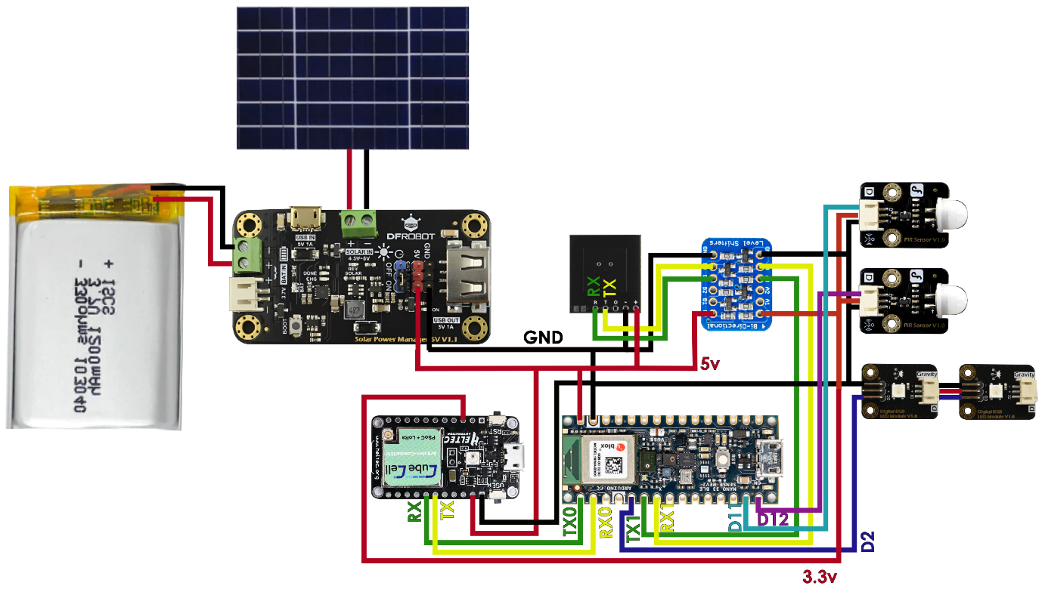

Figure 5.1 Hardware Circuit Connection Diagram

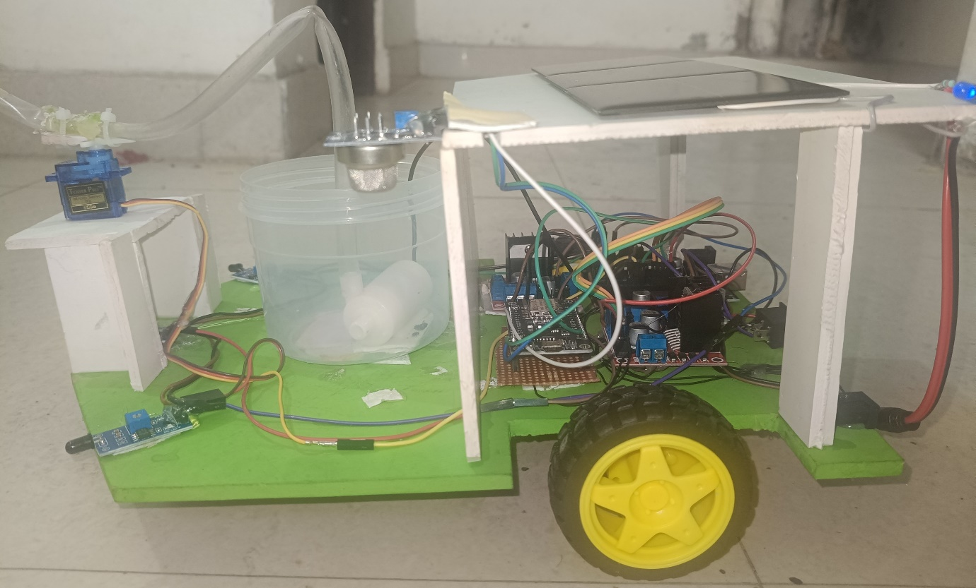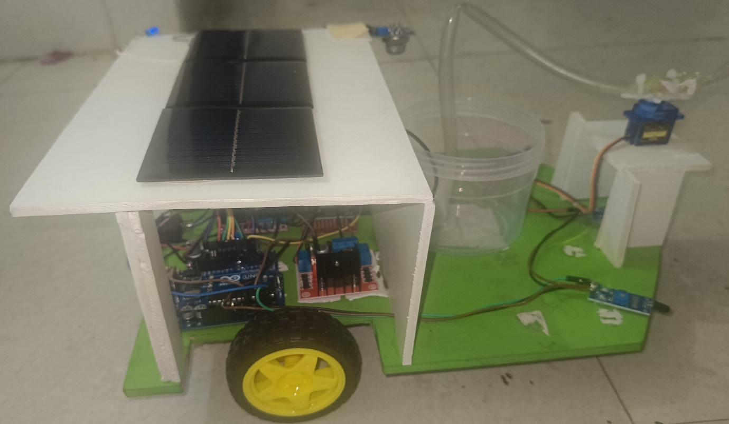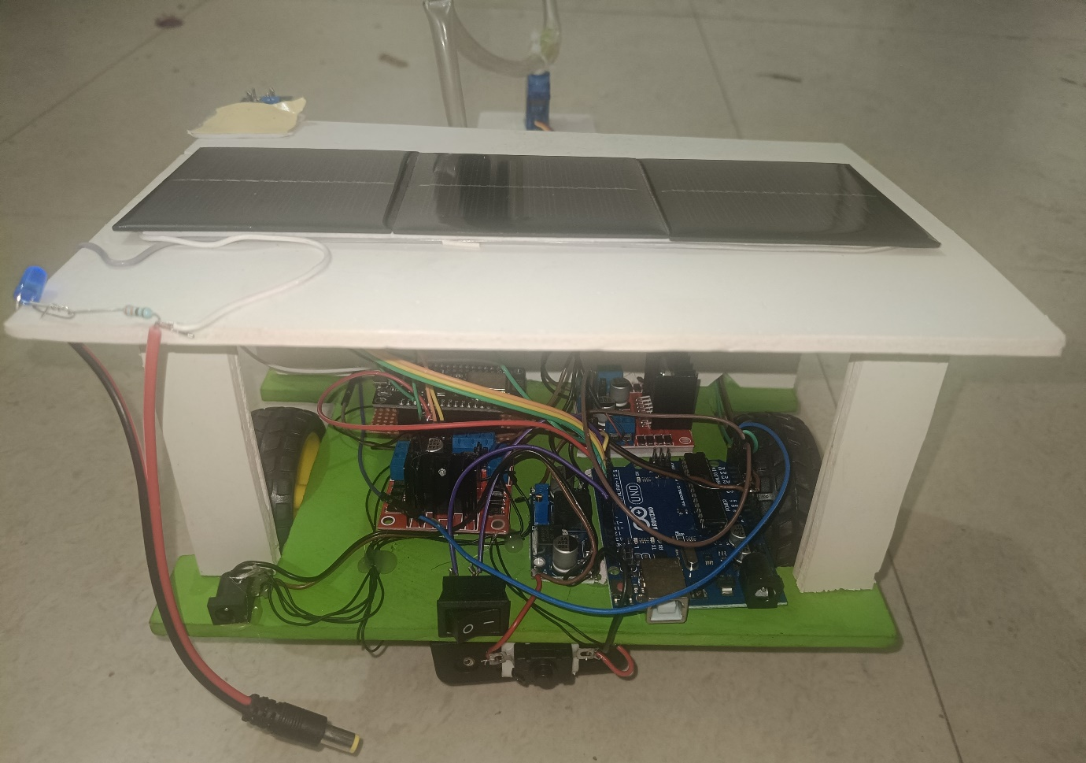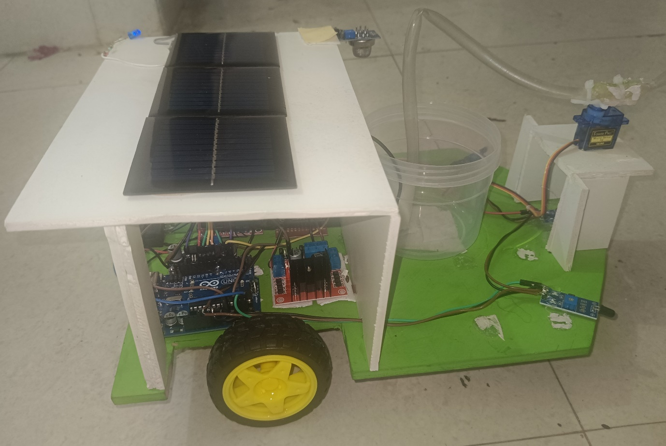
Figure 5.2 Hardware Setup of Proposed System

Step 4: Multidirectional Sensing Array Calibration
Three infrared flame sensors are strategically positioned in a fixed array to provide a comprehensive 180-degree field of detection. These sensors are calibrated to convert light intensity from infrared thermal signatures into analog signals for the Arduino. Each sensor—positioned at left, center, and right angles—is assigned a specific sensitivity threshold to eliminate "blind spots". The calibration process involves testing the sensors at various distances to ensure they can accurately identify a fire source coordinates. By synchronizing these inputs, the robot can determine the exact direction of a flame and initiate autonomous navigation. This perception layer is critical for the robot's ability to maintain high sensing accuracy in a dynamic hazardous environment.
Step 5: Suppression and Active Sweeping Mechanism Installation
The fire suppression mechanism is assembled by mounting a submersible water pump inside an onboard water reservoir. A front-mounted servo motor is installed to carry the water nozzle and is connected to the Arduino’s PWM pins for precise control. The mechanical setup allows for "active sweeping," which is the dynamic movement of the nozzle across the base of the fire. The submersible pump is linked through a relay module that activates only when the robot is within the proximity of the target. This implementation ensures that the extinguishing agent is directed efficiently, covering the entire fire zone rather than just a fixed point. The servo's range is calibrated to match the 180-degree detection field provided by the flame sensors
Step 6: Gas and Smoke Verification Layer Setup
Beyond thermal signatures, an MQ-series smoke sensor is mounted on the chassis to provide a secondary layer of hazard verification. This sensor is calibrated to analyse air quality and detect concentrations of smoke or flammable gases that exceed safety limits. The Arduino is programmed to arm the fire suppression system only when both flame and smoke thresholds are satisfied. This dual-verification logic reduces the probability of false alarms caused by non-fire heat sources like sunlight or infrared LEDs. The sensor's raw data is also processed to be sent as part of the real-time status logs for remote monitoring. Integrating gas detection enhances the robot's role as a first responder in high-smoke areas where visibility is zero.

Step 7: Embedded Logic and Firmware Development
Using the Arduino IDE and C++ programming, the localized control logic is developed and uploaded to the Arduino Uno. The firmware handles real-time navigation, obstacle avoidance, and the coordination of the "Sense-Analyse-Act" cycle. Specialized algorithms are written to process inputs from the three flame sensors and translate them into motor and servo movements. This code also manages the feedback loop, ensuring the submersible pump only activates when fire density thresholds are reached. Every suppression mission relies on the reliability of this 8-bit architecture to execute tasks without latency or processing errors. The software is tested through multiple iterations to ensure the robot can target thermal sources autonomously and accurately.
Step 8: IoT Bridge and Link Communication Setup:
The NodeMCU is configured to act as the primary IoT bridge between the robotic hardware and the global internet. It is programmed to establish a Wi-Fi connection through a local network or mobile hotspot for cloud-based communication. A serial data link is created between the Arduino and the NodeMCU to facilitate the exchange of status logs and manual commands. This setup allows the system to overcome the short-range limits of Bluetooth or RF protocols used in conventional robots. The communication bridge ensures that real-time environmental data is transmitted to the remote user interface continuously. This long-range connectivity is the foundation for the robot's ability to be monitored from thousands of miles away.
Step 9: Android GUI Interface Deployment
A custom Android-based Graphical User Interface (GUI) is deployed to serve as the presentation layer for remote human monitoring. The interface is designed to display live system status, such as identifying if the current environment is "Fire Detected" or "Safe". It also features manual directional arrows that provide the operator with granular control over the vehicle's position. This manual override is vital for recovering the robot to a safe zone or docking station after a fire is neutralized. The GUI acts as the command centre, allowing a remote user to intervene if the autonomous logic encounters complex obstacles. By integrating this interface, the system achieves a balance between automated response and human-led strategic oversight.

Step 10: System-Wide Validation and Field Testing
The final step involves comprehensive field testing to validate the robot's performance under simulated fire conditions. The "Sense-Analyse-Act" cycle is monitored to ensure the robot identifies a flame source and activates suppression within seconds. Sensing accuracy is confirmed by checking if the 180-degree sensor array effectively eliminates blind spots during target acquisition. The efficiency of the hybrid power system and the "active sweeping" suppression mechanism is recorded and analysed for technical reliability. Testing also confirms that the NodeMCU maintains a stable serial data link with the Android GUI over varying distances. This final validation phase ensures the robot is mission-ready for deployment in real-world hazardous environments.

  - HARDWARE INTEGRATION:
The hardware integration phase involves the systematic merging of electronic components, power systems, and mechanical structures into a single cohesive firefighting unit. Each subsystem is calibrated to ensure that data flows seamlessly from the perception layer to the processing core and finally to the execution actuators.
Step 1: Primary Controller and IoT Bridge Synchronization
The integration begins with mounting the Arduino Uno and NodeMCU (ESP8266) onto the central chassis to form the dual-core processing layer. A serial communication link is established between the two boards, allowing the Arduino to handle time-critical localized logic while the NodeMCU manages the Wi-Fi-based cloud connectivity. This setup requires precise voltage regulation to prevent noise interference between the 5V Arduino and the 3.3V NodeMCU logic levels. The wiring is organized to ensure that the IoT bridge can transmit real-time sensor logs to the Android GUI while simultaneously receiving manual override commands. This dual-processor architecture is the foundation for achieving both hardware-level autonomy and global remote oversight.
Step 2: Multidirectional Sensing Array Mounting
The perception layer is integrated by positioning three infrared flame sensors in a fixed array to provide a comprehensive 180-degree field of detection. These sensors are mounted at specific angles—left, centre, and right—to capture directional heat data and eliminate detection "blind spots" common in single-sensor models. Each sensor is interfaced with the Arduino’s analogy pins, where thresholds are calibrated to convert infrared signatures into actionable digital coordinates. The alignment of the array is critical, as it directly informs the autonomous navigation logic for target acquisition. By synchronizing these inputs, the system ensures high sensing accuracy during the initial reconnaissance phase of a hazard.

Step 3: Gas and Smoke Verification Integration
An MQ-series smoke sensor is integrated into the sensing layer to provide secondary hazard verification alongside the thermal data. This sensor is mounted on the edge of the chassis, as seen in side-view documentation, to monitor air quality and detect concentrations of flammable gases. The sensor’s output is calibrated to trigger a "System Status" alert on the Android GUI if smoke density exceeds predefined safety levels. This secondary verification layer is programmed to arm the fire suppression system only when both flame and smoke thresholds are satisfied. The integration of gas detection enhances the robot's reliability in high-smoke areas where visual or infrared data alone might be insufficient.
Step 4: Hybrid Power Infrastructure Wiring
The power system is integrated using a dual-input architecture that combines a 12V monocrystalline solar panel with an AC-to-DC charging circuit. These sources are wired to a central Li-ion battery bank through a charging controller that prioritizes renewable energy during daylight hours. This hybrid setup ensures mission sustainability in off-grid locations by providing a continuous energy supply for the microcontrollers and high-current motors. Wiring includes protective diodes to prevent backflow and ensure stable power delivery during the transition between solar and AC modes. The entire power bank is mounted securely to provide a low centre of gravity for the robotic chassis.
Step 5: Precision Suppression Actuator Alignment
The suppression mechanism is integrated by mounting a front-facing servo motor that carries the water delivery nozzle. This servo is connected to the Arduino’s PWM pins, allowing the controller to dynamically adjust the nozzle's angle based on the highest flame sensor reading. The mechanical alignment is designed to achieve "Active Sweeping," where the nozzle moves back and forth to ensure water covers the entire base of the fire. The servo is positioned to match the $180 Degree field of view of the flame sensing array, ensuring that suppression is always aligned with detection. This dynamic setup prevents water waste and increases the efficiency of the onboard reservoir.
Step 6: Mobility and Motor Driver Execution Layer:
The execution layer for mobility is integrated by mounting DC motors onto the chassis, controlled by an L298N motor driver module. The motor driver is interfaced with the Arduino’s digital pins to manage the speed and direction of the robotic platform. High-current wiring is used to connect the motor driver directly to the Li-ion battery bank to ensure sufficient torque for moving the water-filled reservoir. The logic is programmed to initiate turns based on sensor data; for example, if the left sensor detects a fire, the driver activates the right wheels to turn the robot toward the target. This integration is vital for autonomous navigation and manual recovery via the Android GUI.
Step 7: Submersible Pump and Reservoir Plumbing
The suppression system plumbing involves placing a high-pressure submersible pump inside a transparent water reservoir mounted on the chassis. A flexible hose connects the pump to the servo-controlled nozzle at the front of the robot. The pump is wired through a relay module, which acts as an electronic switch controlled by the Arduino to activate water delivery. This reservoir system allows the robot to carry its own extinguishing agent, making it effective in remote zones without external plumbing. The pump is only activated when the robot reaches a proximity threshold, ensuring that the water stream is delivered accurately to the thermal source.
Step 8: Presentation Layer and GUI Linkage
The final stage of integration involves linking the hardware to the Android-based Graphical User Interface (GUI) via the NodeMCU cloud bridge. The GUI is configured to receive serial data packets that provide real-time status updates on environmental hazard levels. It also features a control interface with directional arrows, which are mapped to specific movement commands processed by the motor driver. This manual override capability allows the user to recover the vehicle to a safe zone after the autonomous suppression cycle is complete. The presentation layer effectively bridges the gap between the robot's physical actions and the operator’s remote oversight.

Figure 5.3: Hardware Integration Setup

  - SYSTEM TESTING AND VALIDATION:
The system testing and validation phase focuses on ensuring that the integrated hardware and software components meet the operational requirements for autonomous sensing and remote long-range control. This process involves rigorous field testing to verify the synchronization of the Sense-Analyze-Act cycle and the reliability of the IoT communication link The following test cases were conducted during system evaluation: -
5.3.1 Autonomous Target Acquisition Testing: The robot was tested to confirm its ability to identify a flame source and navigate toward it within seconds of ignition. Validation ensured that the logic initiates directional turns—such as turning left if the left sensor is high—until the center sensor is triggered, ensuring the robot faces the fire directly.
5.3.2 Sensor Coverage and Accuracy Validation: Testing verified that the three-flame sensor array effectively provides 180-degree coverage, successfully eliminating detection "blind spots" found in single-sensor models. The MQ-series smoke sensor was validated to arm the suppression system only after fire density and smoke thresholds were satisfied, reducing false alarms.
5.3.3 Precision Suppression and Active Sweeping: The front-mounted servo motor was tested to ensure it correctly aligns the water nozzle based on the highest flame sensor reading. "Active Sweeping" was validated by confirming the nozzle moves back and forth to cover the entire base of the fire rather than a fixed point, optimizing extinguishing efficiency.
5.3.4 IoT Connectivity and Remote-Control Reliability: The integration of the NodeMCU was validated through seamless serial data transmission between the hardware and the Android GUI. Tests confirmed that the user could monitor real-time status logs and successfully issue manual commands to recover the vehicle to a safe zone via Wi-Fi.
5.3.5 Hybrid Power Sustainability Testing: The dual-input charging circuit was validated by monitoring the transition between solar energy and AC power. Testing confirmed that the hybrid architecture prioritizes renewable harvesting during daylight hours, ensuring the unit remains mission-ready even during power grid failures.
5.3.6 Mobility and Actuation Performance: The L298N motor driver was tested for its ability to manage the robotic chassis torque while carrying a full water reservoir. Validation focused on ensuring the robot could maintain mobility on flat surfaces and respond accurately to both autonomous thresholds and manual override signals.
5.3.7 Hardware and Software Synchronization: Final validation focused on the successful synchronization of data from three flame sensors, one smoke sensor, and the servo motor to create a cohesive response loop. This synchronization was verified by observing the robot's ability to execute complex tasks, such as simultaneous target acquisition and "Active Sweeping" suppression.
5.3.8 Emergency Recovery and Fail-Safe Procedures: The manual override via the Android application was validated as a fail-safe measure for post-operation vehicle positioning. Testing ensured that if the autonomous logic encountered a complex obstacle, a remote user could intervene and navigate the platform back to a docking station or safe zone.

  - RESULT ANALYSIS:
The result analysis for the "Solar Powered Wi-Fi controlled Fire Fighting Robot" demonstrates a successful integration of autonomous hardware response and global connectivity. The technical evaluation focuses on the efficiency of the "Sense-Analyse-Act" loop and the reliability of the hybrid infrastructure. Technical results indicate that the response time is highly optimized, with the system identifying and navigating toward flame sources within seconds of ignition. Sensing accuracy was significantly improved through the multidirectional array, which successfully eliminated "blind spots" by providing full 180-degree coverage. This multi-input synchronization between the three flame sensors, the smoke sensor, and the servo motor created a cohesive and reliable response cycle. The suppression phase showed optimized efficiency due to the implementation of the servo-controlled "active sweeping" nozzle. This dynamic system allowed the robot to target fire at multiple angles without moving the entire chassis, which saved both battery power and time. The high-pressure submersible pump effectively delivered water from the onboard reservoir to neutralize thermal targets precisely. Power sustainability was validated through the hybrid charging system, which prioritized solar harvesting during daylight hours. This architecture extended the standalone operational uptime and ensured the unit remained mission-ready even during total power grid failures. The L298N motor driver effectively managed the chassis mobility, ensuring the robot could handle the weight of the water reservoir during autonomous navigation. Connectivity reliability was confirmed via the NodeMCU, which allowed for seamless serial data transmission between the robot and the Android GUI. Users were able to monitor real-time "System Status" logs and environmental hazard levels from vast distances via Wi-Fi. The manual recovery feature proved successful, allowing remote operators to navigate the vehicle back to a safe zone using directional arrows after fire neutralization was complete.

CHAPTER 6: CONCLUSION AND KEY FINDINGS

  - CONCLUSION:

6.1.1. Overcoming Communication Range Barriers: The implementation of the NodeMCU IoT bridge successfully transitioned the robot from short-range RF/Bluetooth protocols to a global internet-based control system. This ensures that the platform is no longer restricted by a 500-meter radius, allowing for monitoring from virtually any location. By utilizing a cloud-linked Android GUI, the operator maintains high-fidelity oversight and command capabilities across vast distances. This technical leap is fundamental for deploying robots in massive industrial complexes where traditional wireless signals often fail or degrade.

6.1.2. Sustainable Hybrid Power Architecture: The project successfully integrated a 12V monocrystalline solar panel with an AC-to-DC charging circuit to create a self-sustaining energy ecosystem. This hybrid setup prioritizes renewable energy harvesting during daylight hours while maintaining grid compatibility for 24/7 mission readiness. By ensuring the Li-ion battery bank remains charged in off-grid locations, the robot eliminates the risk of mission failure due to power depletion. This makes the system ideal for remote hazardous zones where human intervention is impossible, and power infrastructure is non-existent.

6.1.3. Precision Sensing and Hazard Verification: A critical achievement of this project is the elimination of detection blind spots through a strategic 180-degree multi-sensor array. By combining three IR flame sensors with an MQ-series smoke sensor, the system achieves a dual-layer verification process for every identified hazard. This logic ensures that the suppression mechanism only activates when both thermal and smoke thresholds are satisfied, significantly reducing false alarms. The high accuracy of the perception layer allows the robot to calculate precise coordinates for autonomous navigation in zero-visibility conditions.

6.1.4. Efficient Suppression via Active Sweeping: The introduction of a servo-controlled "active sweeping" nozzle has revolutionized the efficiency of localized fire extinguishing in this prototype. Unlike fixed nozzles that wastewater on a single point, this dynamic system moves the water stream back and forth across the base of the fire. This approach ensures maximum coverage and faster cooling of the hazard while optimizing the limited resources of the onboard water reservoir. The synchronization between the sensing array and the servo motor allows for high-precision targeting without repositioning the entire chassis.

6.1.5. Seamless Dual-Core Logic Integration: The architectural decision to utilize both an Arduino Uno and a NodeMCU provided a stable and lag-free environment for complex multi-tasking. The Arduino handles the high-speed localized navigation and relay control, while the NodeMCU manages the communication overhead of the IoT serial data transmission. This separation of concerns prevents processing bottlenecks that often occur in single-processor systems during simultaneous sensing and streaming. The resulting stability allows the robot to maintain autonomous suppression cycles while providing the user with real-time data feed.

6.1.6. Strategic Human Safety and Risk Mitigation: The primary justification of this work was the protection of human life, which has been achieved by creating a reliable robotic first responder. This unit is designed to enter toxic, high-temperature, or explosive zones that would be lethal for human firefighters to access during the initial breakout. By acting as the first line of defense, the robot can suppress flames or monitor gas levels before human teams arrive on the scene. This proactive approach significantly reduces the potential for casualties and large-scale property damage in industrial environments.

6.1.7. Real-Time Transparency through Android GUI: The development of a custom Android-based Graphical User Interface has provided a transparent and user-friendly window into the robot's environmental surroundings. The GUI displays live status logs and environmental data, allowing remote operators to stay informed about the severity of a hazard in real-time. This presentation layer acts as the central command hub, bridging the gap between physical hardware and the human strategist. The ability to view "Fire Detected" or "System Safe" alerts instantly enhances the speed of decision-making during emergencies.

6.1.8. Manual Override and Vehicle Recovery Logic: Beyond autonomous operation, the project successfully implemented a manual override system to ensure the safe recovery of the hardware post-mission. Using the directional arrows on the mobile application, a remote user can navigate the robot back to a docking station or safe zone after a hazard is cleared. This feature is vital for recovering the platform from complex disaster sites where the autonomous logic might encounter unexpected physical debris. This balance of automation and human control ensures that the robot remains a manageable and retrievable asset.

6.1.9. High-Torque Mechanical Reliability: The mechanical integration of the L298N motor driver and high-torque DC motors proved capable of handling the payload of a full suppression system. The chassis maintained consistent mobility and turning accuracy even while carrying the significant weight of the water reservoir and hybrid power components. This mechanical reliability is crucial for navigating thermal sources quickly before they escalate into larger uncontrolled fires. The structural integrity of the design ensures that the electronic components remain protected from heat while the robot executes its mission.

6.1.10. Technical Foundation for Future Scaling: This project stands as a robust proof-of-concept that demonstrates how modern IoT and renewable energy technologies can be harmonized for safety applications. The modular nature of the hardware and software architecture allows for easy future upgrades, such as the integration of computer vision or AI-driven swarm logic. By meeting all design objectives, the system validates the feasibility of using low-cost embedded systems to solve high-stakes disaster management problems. It paves the way for more advanced, autonomous disaster-relief robotics that can operate globally.

  - KEY FINDINGS:
6.2.1. Elimination of Traditional Range Constraints: The integration of the NodeMCU (ESP8266) successfully bypassed the standard 500-meter range limitation inherent in traditional RF and Bluetooth-controlled systems. By utilizing the internet as a medium for serial data transmission, the system achieved a global communication link that allows for monitoring from vast distances. This ensures that a remote operator in a completely different city can still receive real-time status updates and maintain oversight of the robotic platform. The transition to a cloud-based communication protocol effectively transforms the robot from a localized tool into a global IoT asset. This technical leap is fundamental for modern industrial applications where disaster sites may be restricted or located in remote, inaccessible areas.

6.2.2. 180-Degree Detection via Multi-Sensor Array: A significant breakthrough was the successful elimination of detection "blind spots" through the strategic positioning of three IR flame sensors. By mounting these sensors at precise angles—left, centre, and right—the system provides a comprehensive 180-degree field of view for thermal reconnaissance. This configuration allows the Arduino Uno to calculate directional coordinates with high accuracy, ensuring the robot turns exactly toward the identified fire source. Unlike single-sensor models that require the entire chassis to spin for detection, this multidirectional array initiates target acquisition instantly upon sensing heat. This finding underscores the importance of sensor fusion in reducing response time during the critical initial seconds of a fire breakout.

6.2.3. Secondary Hazard Verification for False Alarm Reduction: The project confirmed that integrating an MQ-series smoke sensor alongside flame sensors provides a vital secondary layer of hazard verification. This dual-layer logic ensures that the fire suppression system is only armed when both thermal signatures and smoke density thresholds are simultaneously satisfied. This technical finding is crucial for preventing false alarms caused by non-fire infrared sources, such as direct sunlight or reflective industrial lighting. By requiring two distinct environmental triggers, the system maintains high operational reliability and avoids the wasteful deployment of extinguishing agents. This verified sensing strategy enhances the robot's role as an intelligent first responder capable of distinguishing between real threats and environmental noise.

6.2.4. Optimized Suppression via Active Sweeping Mechanisms: Experimental evaluation proved that the implementation of a servo-controlled "active sweeping" nozzle is significantly more efficient than using fixed-point water delivery. The front-mounted servo motor dynamically moves the nozzle back and forth across the entire base of the fire, ensuring maximum coverage and faster cooling. This movement logic allows the robot to neutralize flames at multiple angles without the need for constant repositioning of the heavy robotic chassis. By targeting the fire more effectively, the system significantly reduces the volume of water required to achieve total suppression of a thermal hazard. This finding is particularly important for autonomous units with limited onboard reservoir capacity, as it maximizes the impact of every millilitre of water used.

6.2.5. Power Mission Sustainability through Hybrid Infrastructure: The hybrid power architecture, combining a 12V monocrystalline solar panel with an AC charging circuit, successfully demonstrated 24/7 mission readiness. This setup ensured that the onboard Li-ion battery bank remained charged in off-grid environments by prioritizing renewable energy harvesting during daylight hours. The system automatically switches to AC power as a backup when solar intensity is low, effectively preventing mission failure due to battery depletion. This technical capability is essential for long-duration monitoring tasks in remote industrial zones where constant human maintenance is not feasible. The finding validates that sustainable energy sources can be harmonized with robotic systems to maintain safety infrastructure without reliance on the traditional power grid.

6.2.6. Dual-Core Logic Stability and Latency Prevention: The architectural decision to separate localized navigation logic from global communication tasks resulted in a highly stable, lag-free system. By utilizing the Arduino Uno for real-time sensor processing and the NodeMCU for IoT connectivity, the robot avoided the processing bottlenecks common in single-core systems. This "Sense-Analyses-Act" cycle remained synchronized even while high-bandwidth serial data was being transmitted to the cloud-based Android interface. The finding highlights that a dual-processor approach is superior for robotics that must handle simultaneous high-speed movement and remote data logging. This stability ensures that the robot can autonomously suppress a fire while a human operator thousands of miles away views a consistent, live status feed.

6.2.7. Real-Time Transparency through Android-Based GUI: The development of a custom Android-based Graphical User Interface provided a transparent window into the robot's environmental conditions in real-time. This interface successfully displayed "System Status" logs, such as "Fire Detected" or "Safe," allowing for immediate strategic oversight by a remote operator. The GUI acted as the primary presentation layer, translating complex serial data from the NodeMCU into a user-friendly format for emergency management. This finding confirms that providing humans with clear, live environmental data significantly improves the speed and accuracy of decision-making during crises. The success of this interface demonstrates how IoT connectivity can bridge the gap between physical hardware in a dangerous zone and a safe remote command centre.
6.2.8. Manual Override as a Critical Recovery Fail-Safe: Beyond the autonomous suppression cycle, the manual override feature via the Android application proved to be a critical fail-safe for vehicle recovery. This function allowed the remote user to take control of the robot’s movement using directional arrows once the fire hazard was neutralized. This finding is vital for repositioning the hardware in complex disaster sites where physical debris or shifting environments might confuse purely autonomous navigation. The ability to manually guide the robot back to a docking station or safe zone ensures the preservation of the robotic asset after its mission. It provides a balanced operational model where robotic autonomy handles the immediate danger while human intelligence manages the final recovery and positioning.

6.2.9. High-Torque Performance and Mechanical Stability: Mechanical testing validated that the L298N motor driver and high-torque DC motors could successfully manage the payload of a full water-filled reservoir. The robotic chassis maintained consistent movement speed and turning precision despite the significant weight of the hybrid power components and suppression hardware. This finding ensures that the robot can move rapidly toward a thermal source before the fire escalates into a larger, uncontrollable event. The structural integrity of the chassis also protected the sensitive electronic microcontrollers from the heat generated during the suppression phases of field testing. Maintaining mechanical stability under load is a key finding for the design of mobile robots intended for heavy-duty industrial or emergency response roles.

6.2.10. Scalability for Future AI and Swarm Integration: The project findings established a robust and modular technical foundation that is highly suitable for future scaling and advanced upgrades. The modular nature of both the hardware wiring and the C++ software logic allows for the easy integration of computer vision, 3D LiDAR, or AI-driven logic. This prototype proves the feasibility of using low-cost embedded systems to solve high-stakes safety problems, making it a viable model for swarm robotics in disaster management. Future iterations can build upon this Wi-Fi-controlled framework to coordinate multiple robots for large-scale fire suppression in massive forest or industrial zones. This project stands as a successful proof-of-concept that harmonizes IoT, renewable energy, and autonomous robotics into a life-saving disaster mitigation platform. The implementation of SHA-256 hashing improved system security by protecting administrator credentials through encrypted password storage. This reduced the possibility of unauthorized access and enhanced authentication reliability.

CHAPTER 7: CONTRIBUTIONS AND FUTURE ENHANCEMENTS
  - CONTRIBUTIONS:
The development of this project has resulted in several significant contributions to the fields of robotics, Internet of Things (IoT), and disaster management. These contributions highlight the technical advancements and practical applications of the system:
7.1.1 Elimination of Geographic Constraints: This project contributes a scalable model for overcoming the traditional 500-meter range limit of RF-controlled robotics. By utilizing a Wi-Fi-based IoT bridge, it establishes a framework for global remote oversight, allowing safety personnel to monitor hazards from any location with internet access.
7.1.2 Development of a Hybrid Power Model: It introduces a sustainable power architecture that combines renewable solar energy with AC grid backup. This contribution ensures that autonomous safety systems can remain operational in off-grid or disaster-stricken areas where the primary power infrastructure has been compromised.
7.1.3.Implementation of a Dual-Core Intelligence Framework: The project demonstrates a successful "split-task" architecture using an Arduino Uno and NodeMCU. This contribution provides a blueprint for separating time-critical localized hardware logic from high-bandwidth communication tasks, preventing system latency during emergencies.
7.1.4.Advancement in Multidirectional Sensing: By utilizing a 180-degree sensing array, the project contributes a method for eliminating detection "blind spots." This allows for more accurate target acquisition than single-sensor systems, ensuring that thermal signatures are identified instantly regardless of the robot’s initial orientation.
7.1.5 Precision Suppression via Active Sweeping: The project contributes a dynamic extinguishing mechanism using a servo-controlled nozzle. This "active sweeping" logic ensures more efficient use of onboard resources, such as water, by covering a wider fire base without requiring the constant movement of the entire robotic chassis.
7.1.6 Reduction of Human Risk in Hazardous Zones: A major humanitarian contribution is the creation of a "First Responder" system that replaces humans in toxic or explosive environments. This significantly reduces the likelihood of casualties by deploying autonomous hardware into high-risk areas during the initial breakout of a fire.
7.1.7 Integration of Secondary Hazard Verification: The project contributes a dual layer verification logic using both flame and smoke sensors. This reduces the frequency of false alarms in industrial settings, ensuring that suppression resources are only deployed when a legitimate fire threat is confirmed by multiple data points.
7.1.8 Deployment of a Cloud-Linked Presentation Layer: It contributes a custom Android-based GUI that provides real-time transparency into environmental conditions. This allows for data-driven decision-making by providing remote operators with live status logs and environmental readings directly from the hazard site.
7.1.9 Creation of a Manual Recovery Fail-Safe: The project introduces a remote manual override feature for post-mission vehicle positioning. This contribution ensures the long-term viability of the robotic asset by allowing operators to navigate the platform back to a safe zone if the autonomous logic encounters physical obstacles.
7.1.10 Foundational Framework for Future AI Upgrades: Finally, the project provides a modular hardware and software framework that serves as a technical foundation for the next generation of disaster robotics. It paves the way for future research into swarm coordination, computer vision, and AI-driven predictive hazard mapping.

7.2 UNIQUE FEATURES:
The "Solar Powered Wi-Fi controlled Fire Fighting Robot" stands out from conventional firefighting platforms due to several innovative design choices that prioritize range, sustainability, and precision.
7.1.1 Global IoT Range Extension: Unlike traditional robots restricted by a 500-meter RF or Bluetooth radius, this system uses a NodeMCU bridge to facilitate control via the internet. This allows the robot to be monitored and managed from virtually anywhere in the world, provided there is a Wi-Fi or hotspot connection.
7.2.2 180° Blind-Spot Elimination: Most entry-level robots use a single flame sensor, requiring the robot to constantly rotate to find a fire. This system features a triple-sensor array mounted at offset angles, providing a full 180-degree field of view for instantaneous thermal target acquisition without moving the chassis.
7.2.3 Active Sweeping Suppression: Rather than using a fixed-point nozzle, this robot utilizes a front-mounted servo motor to create a dynamic "sweeping" motion. This mimics the movement of a human firefighter, allowing the water stream to cover the entire base of the fire and optimize the use of the onboard water reservoir.
7.2.4 Hybrid Energy Ecosystem: A standout feature is the dual-input power architecture, which combines a 12V monocrystalline solar panel with an AC-to-DC charging circuit. This ensures the robot can harvest renewable energy for off-grid sustainability while maintaining grid-compatibility for 24/7 mission readiness.
7.2.5 Dual-Verification Logic: To prevent false alarms—a common failure in IR-based systems—the robot implements a dual-trigger protocol. The suppression system is only armed when both the IR flame sensors and the MQ-series smoke sensor satisfy their respective thresholds, ensuring high operational reliability.
7.2.6 Bi-Directional Cloud Feedback: The system provides real-time System Status Logs (e.g., "Fire Detected" or "System Safe") directly to an Android-based GUI. This creates a transparent feedback loop where the user is not just controlling the robot but receiving live environmental data from the hazardous zone.
7.2.7 Remote Manual Recovery: While the robot is fully autonomous in its suppression cycle, it features a unique manual override for post-operation recovery. This allows the operator to use directional arrows on their smartphone to guide the robot back to a docking station, ensuring the hardware is never stranded in a disaster zone.

7.3 FUTURE SCOPE:
While the current prototype successfully bridges the gap between hardware autonomy and IoT connectivity, there is significant potential for scaling the system into a more advanced disaster management platform. The modular nature of the architecture allows for the following future enhancements:
7.3.1 Computer Vision and Image Processing: Integrating a Raspberry Pi or an ESP32-CAM would enable real-time video streaming and AI-based object detection. This would allow the robot to distinguish between different types of fire (e.g., electrical vs. chemical) and navigate around complex obstacles more effectively using edge-detection algorithms.
7.3.2 Swarm Robotics Coordination: The system could be scaled into a "Swarm Intelligence" framework where multiple robots communicate with each other over the cloud. This coordination would allow a fleet of robots to surround a large-scale industrial fire, sharing sensor data to suppress the hazard from multiple angles simultaneously.
7.3.3 Advanced Gas Chromatography: Upgrading the sensing layer with specialized sensors for toxic gases (such as Carbon Monoxide, Ammonia, or Methane) would turn the robot into a comprehensive environmental reconnaissance unit. This data would be vital for human fire teams to determine if an area is safe for entry after the flames are extinguished.
7.3.4 GPS and Autonomous Waypoint Navigation: Integrating a GPS module would allow the robot to be deployed at specific coordinates in large open-field environments, such as forest fires. The robot could then autonomously navigate back to a home base for water refills and battery charging without any human intervention.
7.3.5 Multi-Agent Suppression Systems: Future versions could feature multiple nozzles capable of discharging different extinguishing agents, such as $CO_{2}$ or fire-suppressant foam. A specialized logic layer would then select the appropriate agent based on the data received from the environmental sensors.
7.3.6 Ruggedized All-Terrain Chassis: Upgrading to a tracked (tank-style) chassis with high-clearance suspension would allow the robot to operate in more diverse environments. This enhancement would enable the unit to navigate through rubble, scattered debris, and uneven outdoor terrain typically found at disaster sites.
7.3.7 Voice and Gesture Command Integration: The presentation layer could be expanded to include voice-activated commands or gesture-based controls via the Android application. This would provide field responders with hands-free control options while managing other aspects of a rescue mission.

7.4 FINAL LIMITATIONS:
Despite the successful implementation of the IoT-enabled robotic platform, certain technical and environmental boundaries define its current operational capacity. These limitations provide a roadmap for future hardware and software iterations.
7.4.1 Dependent on Network Infrastructure: The system's "Global Range" is fundamentally dependent on the presence of a Wi-Fi network or mobile hotspot. In the event of a total communication blackout or severe signal interference within a massive metal-reinforced industrial structure, the NodeMCU may lose connectivity, reverting the system to purely autonomous mode without remote human oversight.
7.4.2 Extinguishing Agent Specificity: The current suppression mechanism is exclusively designed for water-based extinguishing. This limits the robot's effectiveness against Class B (flammable liquid) or Class C (electrical) fires, where the application of water could potentially exacerbate the hazard or lead to short circuits within the environment.
7.4.3 Payload and Torque Ratios: The robotic chassis and DC motors are calibrated for the current weight of the onboard water reservoir. Increasing the reservoir capacity to handle larger fires would necessitate a complete redesign of the mobility layer, including high-torque planetary gear motors and a reinforced structural frame to prevent mechanical strain.
7.4.4 Terrain Navigation Constraints: The current four-wheel drive configuration is optimized for flat, indoor surfaces such as warehouse floors or laboratory environments. It possesses limited ground clearance and lack of suspension, making it unsuitable for navigating through heavy debris, steep inclines, or the irregular outdoor terrain often found at major disaster sites.
7.4.5 Power Recovery Latency: While the hybrid solar-AC system ensures sustainability, the rate of energy harvesting via the monocrystalline solar panel is relatively slow compared to the high current draw of the submersible pump and DC motors. Continuous operation over several hours would eventually deplete the battery faster than the solar panel can replenish it during a single mission.
7.4.5 Sensor Sensitivity to Ambient Light: Although the dual-verification logic (Flame + Smoke) reduces false alarms, the IR flame sensors can still be affected by high-intensity ambient sunlight or reflective surfaces in certain outdoor conditions. This requires careful calibration of the sensitivity thresholds to maintain detection accuracy in varying lighting environments.
7.4.6 Processing Architecture Limits: The 8-bit architecture of the Arduino Uno restricts the implementation of high-level computational tasks such as real-time video processing or complex SLAM (Simultaneous Localization and Mapping). Adding more advanced high-bandwidth sensors would require transitioning to a 32-bit processing platform to avoid data bottlenecks.

REFERENCES:
The following references are formatted according to IEEE standards, based on the citations provided in your research paper:
[1] J. Pradeep et al., "Design and Implementation of a Real Time IoT-Based Autonomous Fire Fighting Robot," 2026.
[2] D. Culhane et al., "Implementation of Solar Powered Autonomous Fire Fighting Robot," 2026.
[3] S. Vinodhini et al., "Solar Powered Autonomous Fire Fighting Robot with Ammonium Ball Suppression Technology," 2026.
[4] R. Deng et al., "Autonomous navigation of non-perception firefighting robot through CCTV-informed vision sharing," 2026.
[5] V. Kumar et al., "Fire-fighting robot using Arduino: A Fire Detection and Suppression System," 2025.
[6] M. M. Maruf et al., "Design and Fabrication of an Autonomous Fire Fighting Robot with Multisensory Fire Detection Using PID Controller," 2026.
[7] H. S. Sucuoglu, "Development of Real-Time Fire Detection Robotic System with Hybrid-Cascade Machine Learning Detection Structure," 2025.
[8] W. Ding et al., "A Real-Time Flame Detection and Situation Assessment Algorithm for Firefighting Robots," 2025.
[9] T. Yang et al., "Real-time flame detection and localization for firefighting robots," 2025.
[10] U. Agrawal, "Role of UAV-IoT Networks in Future Wildfire Detection," 2025.
[11] C. M. Chairman et al., "Autonomous Fire-Fighting Robot for Detection and Prevention," 2024.
[12] S. Sunil and C. R. Chaudhari, "Prototype of Fire Fighting Robot," 2024.
[13] S. S. Jadhav et al., "Fire Fighter Robot Using IOT and Mobile Application," 2024.
[14] L. Guruprasad et al., "Autonomous Fire Fighting Robot using Arduino and Multi-Sensor Fusion," 2024.
[15] Y. D. Qiu et al., "Research on Automatic Flame Recognition and Tracking of Intelligent Fire Robot Based on STC89C52," 2023.
[16] Knowledge Hut Research, "Smart Fire Detection System Using MQ-2 Smoke Sensor and Arduino," 2026.
[17] Scribd IoT Technical List, "An Internet of Things Enabled Solar Panel Monitoring and Charging System for Mobile Robotics," 2023.
[18] A. H. Bagdadee et al., "Solar Energy Powered Firefighting Robot: Design, Implementation, and Arduino Code," 2024.
[19] R. Kawate et al., "Multidirectional Sensing and IoT Feedback Mechanism for Industrial Safety Robots," 2024.
[20] Maruf et al., "180° Infrared Flame Detection Unit and Servo-Controlled Water Sprayer for Lab-Scale Firefighting," 2026.

